Making Noise using Analogue Input
- Create circuit diagram as shown below
- Open the Arduino IDE program on your computer

- In the menu at the top of the arduino program go to
File → Examples → 02.Digital → tonePitchFollower
- Upload the code to your arduino
- You will notice turning the potentiometer doesn't affect the buzzer pitch much, that is because the map command isn't correct. By using the Serial Monitor figure out what the range of values the potentiometer gives is and correct the map command so that the initial range it takes is what you found and not 800-1000
- Upload your code and check that the buzzer has a greater range

Extensions
- Add another tone command to make a variable pitch ambulance noise.
- Replace the potentiometer with a light sensor and resistor similar to what we did in worksheet 2.2
- Load up File → Examples → 02.Digital → toneMelody, move buzzer from pin 9 to pin 8, upload code and edit code to make your own song.
Program Code (File → Examples → 02.Digital → tonePitchFollower)

void setup() {
// initialize serial communications (for debugging only):
Serial.begin(9600);
Change input values so buzzer gives out a better range of sounds that we can hear. Map command takes the range 800 – 1000 and maps it to range 100 – 900. The value it returns is the value of sensorReading in its new range so a 'sensorReading' of 800 would return 100, a 'sensorReading' of 1000 would return 900, and a sensor value of 700 (half way between 400 and 1000) would return 500 (half way between 100 and 900)
}

void loop() {
// read the sensor:
int sensorReading = analogRead(A0);
// print the sensor reading so you know its range
Serial.println(sensorReading);
// map the pitch to the range of the analog input.
// change the minimum and maximum input numbers below
// depending on the range your sensor's giving:
int thisPitch = map(sensorReading, 800, 1000, 100, 900);

// play the pitch:
tone(9, thisPitch, 10);
delay(1); // delay in between reads for stability
}
Set buzzer on pin 9 to play a note of pitch 'thisPitch' for 10 milliseconds (0.01 of a second)

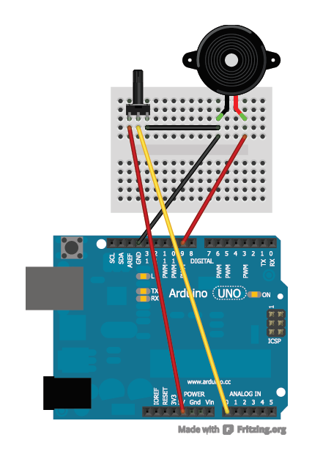
Circuit Diagram
Buzzer
Pin 9
Analog In Pin 0

